 

**GMR INSTITUTE OF TECHNOLOGY**

**An Autonomous Institute Affiliated to JNTUK, KAKINADA**

**GMR NAGAR, RAJAM - 532 127**

**SRIKAKULAM DIST., ANDHRA PRADESH, INDIA**

**SIMULATION OF AC VOLTAGE CONTROLLER USING MATLAB**

An Augmented experiment submitted in partial fulfilment of the requirement of the course

**Experiment Done Using MATLAB simulation**

Submitted by:-

* A. GUNASREE - 20341A0202
* A. TARUNI - 20341A0203
* A. PRATYUSHA - 20341A0204
* A. ANIL KUMAR - 20341A0205
* A. ALEKYA - 20341A0206
* B. ASHISH - 20341A0207

Under the guidance of

Dr Ch. Hemanth Kumar

Dr P. Praveen Kumar

Assistant Professor’s

Department of Electrical and Electronics Engineering

**GMR Institute of Technology**

An Autonomous Institute affiliated to J.N.T. University,

Kakinada NAAC” A” Graded, NBA Accredited, ISO 9001:2008

Certified institution G.M.R. Nagar, Rajam-532127, Srikakulam, A.P

***Faculty In-Charge Head of the Department***

 

CERTIFICATE

This is to certify that the augmented experiment entitled **SIMULATION OF AC VOLTAGE CONTROLLER USING MATLAB** is being submitted by :

has been carried out as a bonafide work in practical fulfilment of the requirements for the completion of the course **“Experiment done using MATLAB simulation”** in Semester- V of our Third year B. Tech

* A. GUNASREE - 20341A0202
* A. TARUNI - 20341A0203
* A. PRATYUSHA - 20341A0204
* A. ANIL KUMAR - 20341A0205
* A. ALEKYA - 20341A0206
* B. ASHISH - 20341A0207

**Signature of course instructor**  **Signature of head of the department**

Dr Ch. Hemanth Kumar, Dr P. Ramana

Dr P. Praveen Kumar Professor and

Assistant Professor’s Head of the Department

Department of EEE Department of EEE

 

ACKNOWLEDGEMENT

It gives me immense pleasure to express a deep sense of gratitude to my guide, **Dr Ch. Hemanth Kumar** **& Dr P. Praveen Kumar**, Assistant Professors, Department of Electrical and Electronical Engineering of wholehearted and invaluable Guidance throughout the report. Without their sustained and sincere effort, this report would not have taken the shape. She encouraged and helped me to overcome various difficulties that I have faced at various stages of my augmented experiment.

I would like to thank **Dr P. Ramana,** Professor & HOD, Department of Electrical and Electronics Engineering, Course coordinator for the Experiment done in the **Simulation-laboratory** for providing all necessary facilities that led to the successful completion of my report

I take the privilege to thank our principal **Dr C. L. V. R. S. V. Prasad**, who made the atmosphere so easy to work. I shall always be indebted to them.

I would like to thank all the faculty members of the Department of Electrical and Electronics for their direct or indirect support and also all lab technicians for their valuable suggestions and for providing excellent opportunities for this augmented experiment.

* A. GUNASREE - 20341A0202
* A. TARUNI - 20341A0203
* A. PRATYUSHA - 20341A0204
* A. ANIL KUMAR - 20341A0205
* A. ALEKYA - 20341A0206
* B. ASHISH - 20341A0207



**AIM:**

To create a model and simulate a severe phase AC voltage controller for different loads by using MATLAB and observing the following waveforms.

**APPARATUS:**

MATLAB SOFTWARE (Latest version)

**THEORY:**

AC voltage controller is a circuit used to convert fixed ac to variable ac without changing the frequency. This conversion with the advent of power electronic devices such as SCR, IGBT, MOSFET, etc. is made very efficiently and flexibly.

The control strategies available to vary fixed ac to variable ac in ac voltage controller circuits

1. On - Off cycle control

2. Firing angle control

3. Integral cycle switching control

By the use of above control strategies the output rms voltage can be varied and hence variable supply can be given to the load. Application such as heating furnaces, pumps, induction motors, lights, blowers, etc. require variable ac supply. The implementation of any converter circuit needs to be tested before going for hardware. This reduces cost, man power, time. This is achieved by using simulation software's were the same model or topology can be tested with the real time hardware ratings and device specifications. One such software for testing power electronic converter circuit is MATLAB and PROTEUS. The application of these software's really prove their worth through their real time applications.

Hence in this paper ac voltage controller circuit working in firing angle control is simulated using MATLAB SIMULINK and PROTEUS software and its output rms voltage is compared.

In this method, the output voltage is controlled by triggering the SCRs TI and T2. By varying the firing angle the rms value of output voltage is varied [4]. Since the sine wave pattern is getting changed, harmonics will be introduced in the system and hence %THD will get increased. The expression for rms value of output voltage for resistive load is given by:

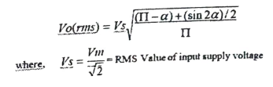



**Steps to create modelling by using MATLAB/SIMULINK:**

1. Click on File New Model.
2. On resulting window click on library Browser, a Simulink library browser will appear.
3. Make/Model the circuit by placing all its Blocks from its which corresponding is clearly shown in the table 1.
4. To get any one of the elements in series RLC branch, such as R, L, or C click on series RLC branch a block in the Simpower System/Element library, and enter the parameters value in such a way that other two elements are invisible. the 5.
5. To change the circuit parameters applicable to the block by double clicking on the block/element and type the values. Keep the values default for some blocks Like thyristor, diode, MOSFET etc.
6. To measure observe the voltage across (or) current passes through the electrical block/device connect voltage measurement (or) current measurement blocks respectively with the ice block, it is available on the library Simpower System/measurement.
7. To observe the waveform in the figure window, the scope block is connected with voltage measurement and current measurement blocks. This scope block is available by on the Library browser Simulink/source scope.

**Steps to simulating the circuit by using MATLAB/SIMULINK:**

1. Click on simulation configuration parameters and make sure that the solver option is 'odel5s (stiff/NDF, it is essential when t circuit contains a power system or power electronics tools. And the stop time value should be 1/50 for 50Hz or 1/60 for 60Hz supply frequency for one cycle.

For 'n' number of cycles, stop time would be n*(1/50) for 50Hz supply, where n=1, 2, 3

1. To run the simulation, select simulation start.
2. To view simulation plots on the simulation window, double-click the scope in the schematic. The scope block corresponding to voltage measurement and current measurement blocks give voltage and current waveforms respectively with respect to time.
3. The waveform obtained are shown in the output graph section and here the output voltage, output current and current through thyristors are shown

**CIRCUIT DIAGRAM:-**

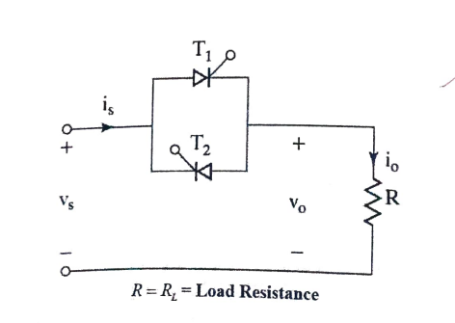

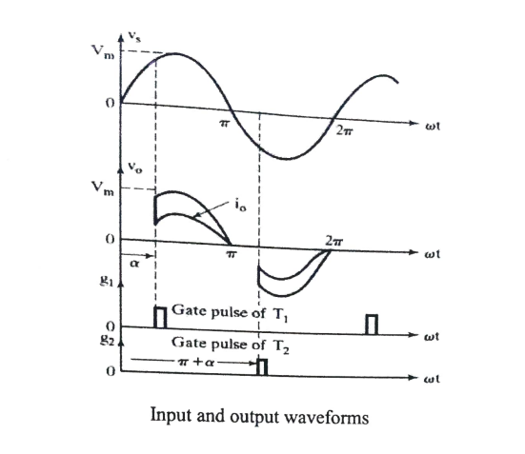



**SCHEMATIC DIAGRAM:-**

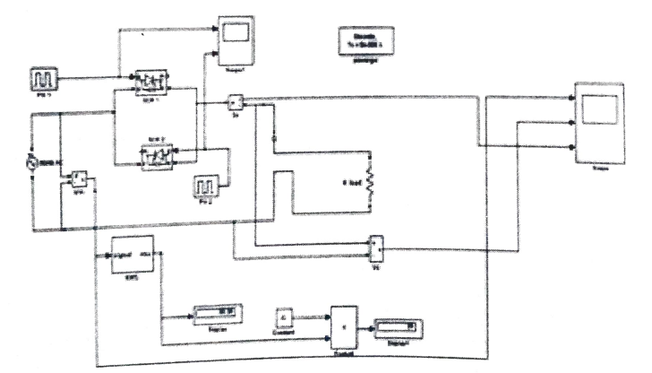

**OUTPUT WAVEFORMS:**





**RESULT:**

Creation and Simulation of the Single phase AC voltage controller for different loads are done using MATLAB and observed the corresponding output waveforms.